ITEM NO: VT-1212; WATTS: 12W
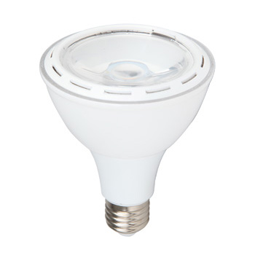
Item No: | VT-1212
SKU Codes | 4268:6000K
Type | PAR30
Base | E27
Real Watts | 12W
EQ. Watts | 60W
Voltage | 220~240V
Input Frequency | 50Hz
Input Efficiency | 62lm/w
Lumen(lm) | 750lm
PF | >0.5
CRI | >80
Color Temperature | 3000K,4500K,6000K
Beam Angle | 40’D
LED Chip | SMD
Driver | Constant Current Non-Isolated Driver
Protection Class | IP20
Body Material | Plastic
Dimmable | No
Unit size | 95mmx114mm
Life Time | 20000hrs
Operation Temperature | -25 ~50’C
Applicable Environment | Indoor Lighting, Used in Home down light, Stairwell lighting.

